Lesson 6

Science and Language Arts

Assignment 1: Science Summarizing Article
Answers will vary.
Legend has it that an apple falling from a tree was the beginning of Isaac Newton’s study of the force of gravitation. Newton is responsible for the Universal law of Gravitation. He recognized that the force of gravity acted on objects causing acceleration. The acceleration of objects due to gravitational force affects objects on earth as well as the moon.
Assignment 2: Science
1. C When the net force(8) stays the same and the mass of 2 doubles to 4, the acceleration decreases from 4 to 2
2. B This equation correctly determines the force by multiplying the mass of the object by the acceleration of the object (change in velocity over time), according to Newton’s Second Law
3. D
4. C Based on Newton’s laws and object in motion moves in a straight line. Since the planet is on a curved path, an outside force (gravity is a force) must be affecting the planet’s path. Therefore, the answer is C
Assignment 3: Sir Isaac Newton and LeBron James
1. B
2. D
3. C
4. B
5. D
6. D
7. C
8. Suggested Answer: The rocket uses its engines to push down on the surface of the Earth. Then the ground pushes the rocket upwards using an equal amount of force.
9. Suggested Answer: This force is created by the energy stored inside his muscles.
10. Suggested Answer: When LeBron James jumps to dunk a basketball, he is using energy to drive force into the court. This force is the “action” that Newton mentioned in his Third Law. The “reaction” comes from the ground pushing LeBron James upwards with an opposite and equal amount of force.
Assignment 4: Using Cellphones and Computers to Transmit Information
1. D
2. C
3. A
4. B
5. D
6. D
7. C
8. Suggested Answer: Responses may range from the general ("Cellphones are used to send and receive information in speedy ways invisible to the human eye.") to the comparatively specific ("Cellphones are used by people to speak with each other over long distances."). As long as the answer comes from the passage, it is acceptable.
9. Suggested Answer: At minimum, students should answer that a cellphone transmits information by connecting to a cellular network. They may add such details as the speaker's voice input being broken down, turned into an electronic signal, and reassembled on the receiving end.
10. Suggested Answer: Answers may vary, as long as they are supported by evidence from the passage. Students may argue that on a literal level, cell phones cannot be described in the same way. Cellphones are devices that use networks to send information; cellphones are not the networks themselves. However, students may also interpret the term "cell phones' ' broadly, encompassing cellular networks. In that case, sharing could be considered a goal of cellphones, given that their purpose (as described in the passage) is to send information from one person to another.

Lesson 6 Math
Assignment 1A: Adding and subtracting fractions
1. 4/9
2. 5/7
3. 1/2
4. 1
5. 1 1/5
6. 1 3/4
7. 5/6
8. 15/16
9. 11/12
10. 19/24
11. 4/5
12. 1 1/20
13.1 1/24
14. 31 2/3
15. 10
16. 27 1/3
17. 10 11/16
18. 14 1/6
19. 7/11
20. 2/9
21. 1/2
22. 1/2
23. 1/4
24. 3/8
25. 1/2
26. 1/2
27. 3 1/2
28. 1 1/5
29. 3 3/8
30. 5 1/10
31. 12 3/5
32. 1/2
33. 1 1/2
34. 4 5/8
35. 7 17/24
36. 1 19/24

Assignment 1B: Multiplying and dividing fractions
1. 6/35
2. 2/3
3. 3/8
4. 23 11/12
5. 1/9
6. 24 7/16
7. 9/28
9. 1 1/3
8. 2 1/3
10. 18
11. 2 92/99
12. 1/5

Assignment 2: Ratios and Proportions
1. 9/10
2. 3/5
3. 2/1
4.
a. 6/1 Whatever comes first in the question is the first number; games played / losses
b. 5/1
c. 1/6
d. 1/5

Assignment 3: Proportions
- 7
- 150 miles
- 30 gallons

Assignment 4: Percents
Problem Part Whole Percent
1. 110 220 50%
2. 6.3 36 17.5%
3. $59,400 $54,000 110%
4. 60 300 20%
5. 75 50 150%
6. 78.3 120 65.25%
7. 42 56 75%
8. 168 1400 12%
9. 1715.8 1492 115%

Assignment 5: Percent of Change
- 7.3%
- 16 2/3% or 16.7%
- 15%
- $97,520

Assignment 6: Proportions and Probability

1. B $\frac{14}{5} = \frac{x}{2}$ obtaining the solution x =$\frac{28}{5}$ = 5.6.

2. D first find the amount of commission by calculating 8% of $4,213 which comes to $337.04. This amount is then added to the weekly salary of $284, giving the answer of $622.04

3. 6.75 you have to find the compound probability of rain on all three day. Convert the three percents to decimals (.30) (.45) (.50) = .0675. Next convert the decimal back to a percent by moving the decimal point two places to the right.

4. C

Lesson 7 Science (and Language Arts)
1. What is the Atomic number of:
Calcium 20
Iron 26
Gold 79
Uranium 92
2. What is the Atomic mass of:
Calcium 40.08
Iron 55.85
Uranium 238.03
Copper 63.54
3. How many protons do the following have?
Calcium 20
Gold 79
Copper 29
Iron 26
4. How many electrons do the following have?
Gold 79
Iron 26
Copper 29
Uranium 92
5. Does mercury have more protons and electrons than tin? Yes
6. Is mercury a heavier element than tin? Yes
7. Does potassium have more electrons than neon? Yes
8. Does hydrogen have more electrons than Uranium? No
9. Which has more protons—sulfur or iodine? Iodine
10. Write the symbols or the names for each of these elements:
Chlorine CC
Copper Cu
Potassium K
Silver AG
Na Sodium
Sn Tin
Zn Zinc
HeliumHe
Iron Fe
P Phosphorus
Ne Neon
Mercury H

Assignment 2
1. 3Fe + 2O2 Fe3O4
2. 2Sr + O2 2SrO
3. Sn + 2NaOH Na2SnO2 + H2
4.2 K + Br2 2KBr
5. 2C8H18 + 25O2 16CO2 + 18H2O
6. 2Sb +3 I2 2 SbI3
7. COCl2 + H2O 2HCl + CO2
8. CS2 + 3O2 CO2 + 2SO2
9. H2SO4 + NaCN 2HCN + Na2SO4
10. 2KClO3 2KCl + 3O2
11. H2 + F2 2HF
12. BaCl2 + 2KIO3 Ba(IO3)2 +2 KCl
13. Mg + 2HCl MgCl2 + H2
14. A. There must be an equal number of atoms of each element on both sides of the equation.
15. A. Place the coefficient 2 in front of oxygen and nitrogen dioxide.
16. C. The coefficient of iodine is 4, oxygen is 9, and the product is 2
17. B. Atom
18. A. These are the physical properties of water.
19. D. The molecular structure has changed.
20.C. Water boiling
21. B. Wood burning
22. C. Glucose is broken down in the presence of oxygen to release energy.

Assignment 3
1. C physical and chemical
2. D the chemical properties of matter
3. A.The explosion of fireworks is an example of a chemical reaction.
4. A a physical change
5.B matter
6. C qualities or characteristics
7. B namely
8. Suggested answer: Students may name any physical property mentioned in the passage. Examples include mass, buoyancy, and color.
9. Suggested answer: Students may name any chemical change mentioned in the passage. Examples include burning and changing color.
10. Suggested answer: Answers may vary, as long as they are supported by the passage. For instance, students may respond that physical properties are easier to observe because they often do not require anything besides the object itself to see. Observing a chemical property requires the presence of additional matter or a change in conditions. A person can tell at a glance that a stick is brown (a physical property), while they would have to try setting it on fire to determine that it is flammable (a chemical property).
Assignment 4
1. A
2. No Change
3. C – The second sentence in paragraph 2 states that “a man who lived during the Depression talked about his family’s frugalness”. In the third sentence of paragraph 2, the pronoun ‘they’ refers back to his family.
4. C
5. A and C

Assignment 5
1. B
2. C
3. B-The word makeshift used in the excerpt means to substitute something-to turn something into something else temporarily. This infers that the places the people were living were of temporary nature. The word foraged means to search for: to rummage through. The last sentence in the excerpt tells us that people searched through the garbage for food.
Answer C is incorrect. A suburban neighborhood is simply a residential area on the outskirts of a city.
Summary examples:
4. When the stock market crashed people lost jobs and wages fell. As consumers lost the power to buy, businesses failed and people lost their homes, cars and other possessions. Farmers were also affected by the collapse in food prices which led to a loss of land and homes for them as well.
5. During the Great Depression people were jobless. President Hoover encouraged the creation of public jobs, but said he believed it was up to the state and local governments to pay for them.
6. The unemployed blamed Hoover for not helping their situations with government money, so they mockingly called their homes Hoovervilles. They blamed Hoover for their situation and were called “the forgotten man at the bottom of the economic pyramid”.
Assignment 6
1. D
2. C.

Lesson 7 Math
Assignment 1
1. 2$x^{2}$ – 3x + 12 + 4x – 5$x^{2}$
A. What are the like terms?
2$x^{2}$, – 5$x^{2}$
– 3x, 4x
+ 12
B. 2$x^{2}$ – 5$x^{2}$– 3x + 4x + 12
-3$x^{2}$ + x + 12
2. 5$x^{2}$ + 7x + 2$x^{2}$ - 2 + 7 + $x^{2}$
a. What are the like terms?
5$x^{2}$,- 2x^2, $x^{2}$
7x
+ 7, + 2
b. Simplify the expression.
5$x^{2}$ - 2$x^{2}$ +$x^{2}$ + 7x + 7 + 2
4$x^{2}$ + 7+ 9
3. -6 + 2x + 3x = 29
-6 + 5x = 29
5x = 29 + 6
5x = 35
answer x = 7
4. 2y + -1y + -1y + x = -13
2y + -2y + x = -13
0 + x = -13
answer x = -13
5. 6x + -2 + 2x = -2 + 4x + 8
answer x=2
6. x + 2 + 2 + 5x = 19 + x + 5
answer x = 4
7. 3 + 4x + 10 = 5x
answer x = 13

Assignment 2
1. Circle
2. not circled
3. Circle
4. Circle
5. A
6. B
7. degree 5
8. degree 0
9. B
10. B and C
11. B and D
12. degree 2
13. degree 1
14. degree 2
15. degree 2
16. A C E
17.5$x^{3}$ –$x^{2}$ + 9

Assignment 3
1. No
2. No
3. C
4. B
5. 5$g^{2}$ + 9g
6.-$m^{5}$ – 8$m^{2 }$- 10m
7.-12$x^{2}$ + 11x + 1
8. 8$x^{3}$ – 6$x^{2}$ + 14x -4
9. A
10. 9$a^{2}$ + 8b + 5
11. 3$m^{2}$+14m + 3
12. -4.5$x^{2}$ + 60x + 311

Assignment 4
1. Already done for you
2. (3t,-6t) (8$t^{2}$) (-9,-4)
3.3t - 6t + 8$t^{2}$ -9 – 4
4. 8$t^{2}$ – 3t -13
5. Write the expression using addition. This is done by using the distributive property:
3$c^{2}$ +$c^{2}$ +7c +12c -1-9
Identify the like terms:
(3$c^{2}$, $c^{2}$) (7c, 12c) (-1, 9)
Group and write in standard form:
3$c^{2}$ +$c^{2}$ +7c +12c -1-9
4$c^{2}$ + 19c + 8
6. Write the expression using addition. This is done by using the distributive property:
-10x + - 5 + -2$x^{2}$ + 10x
Identify the like terms:
(-10x, 10x) (-2$x^{2}$) (-5)
Group and write in standard form:
-2$x^{2}$ + -10x + 10x + -5
-2$x^{2}$ + -5 or -2$x^{2}$ - 5

7. Write the expression using addition. This is done by using the distributive property:
2$x^{2}$ + 7x + -6 -3$x^{2}$ +2x + -5 + - 2x + -3
Identify the like terms:
(2$x^{2}$ , -3$x^{2}$) (7x, 2x,-2x) (-6,-3,-5)
Group and write in standard form:
2$x^{2}$ + – 3$x^{2}$+7x +2x +-2x +-6 +-3 +-5
-$x^{2}$ + 7 + -14 or -$x^{2}$ + 7 - 14

Lesson 8 Language Arts and Social Studies

Assignment 1

From the Inaugural Address of President John F. Kennedy January 20, 1961
Let every nation know, whether it wishes us well or ill, that we shall pay any price, bear any burden, meet any hardship, support any friend, oppose any foe, to assure the survival and the success of liberty.
So let us begin anew -- remembering on both sides that civility is not a sign of weakness, and sincerity is always subject to proof. Let us never negotiate out of fear, but let us never fear to negotiate.
Finally, whether you are citizens of America or citizens of the world, ask of us here the same high standards of strength and sacrifice which we ask of you. With a good conscience our only sure reward, with history the final judge of our deeds, let us go forth to lead the land we love, asking His blessing and His help, but knowing that here on earth God’s work must truly be our own.

From “Kidnapped” by Robert Louis Stevenson
Here he cast about for a comfortable seat, lighted on a big boulder under a birch by the trackside, sat down upon it with a very long, serious upper lip, and the sun now shining in upon us between two peaks, put his pocket-handkerchief over his cocked hat to shelter him.
By this time, now and then sheering to one side or the other to avoid a reef, but still hugging the wind and the land, we had got round Iona and begun to come alongside Mull. The tide at the tail of the land ran very strong, and threw the brig about. Two hands were put to the helm, and Hoseason himself would sometimes lend a help; and it was strange to see three strong men throw their weight upon the tiller, and it (like a living thing) struggle against and drive them back. This would have been the greater danger had not the sea been for some while free of obstacles. Mr. Riach, besides, announced from the top that he saw clear water ahead.

Assignment 2

1. Hyperbole
2. none
3. Hyperbole –the dress did not actually hurt the man’s eyes-the dress did not harm anything.
4. Hyperbole - this is an extreme exaggeration – bed sheets for diapers - Larry is actually an adult

Assignment 3 - Part 1
1. Oxymoron - An oxymoron is a set of words that when put side by side, seem to be contradictory to one another.. “definite maybe”
2. Paradox - a paradox is a larger sentence, situation or idea that is an apparent contradiction. “I must be cruel to be kind.” It takes the entire sentence to see the meaning.
3. Oxymoron - An oxymoron is a set of words that when put side by side, seem to be contradictory to one another. “a deafening silence”
4. Oxymoron - An oxymoron is a set of words that when put side by side, seem to be contradictory to one another... “honest thief”
5. Paradox - a paradox is a larger sentence, situation or idea that is an apparent contradiction. “No one goes to that store because it is too crowded.”

6. Paradox - a paradox is a larger sentence, situation or idea that is an apparent contradiction. “She was busy doing nothing.”

Assignment 3 - Part 2

“more equal” is the oxymoron
Answers should include the following: Equal by definition means an identical amount. Therefore, one equal thing cannot have more than a thing that is equal to it.

Assignment 4
Personification is underlined in each passage.
Key
His father, Elmo, a huge St. Bernard, had been the Judge’s inseparable companion, and Buck bid fair to follow in the way of his father. He was not so large,--he weighed only one hundred and forty pounds,--for his mother, Shep, had been a Scotch shepherd dog. Nevertheless, one hundred and forty pounds, to which was added the dignity that comes of good living and universal respect, enabled him to carry himself in right royal fashion. During the four years since his puppyhood he had lived the life of a sated aristocrat; he had a fine pride in himself, was even a trifle egotistical, as country gentlemen sometimes become because of their insular situation.

I wandered lonely as a Cloud
That floats on high o’er Vales and Hills,
When all at once I saw a crowd
A host of dancing Daffodils;
Along the Lake, beneath the trees,
Ten thousand dancing in the breeze.

The waves beside them danced, but they
Outdid the sparkling waves in glee: –
A poet could not but be gay
In such a laughing company:
I gaz’d – and gaz’d – but little though

Assignment 5

1. Andrew; a fox
2. He; a cat
3. Smile; sugar
4. His hair; fried chicken

Assignment 6
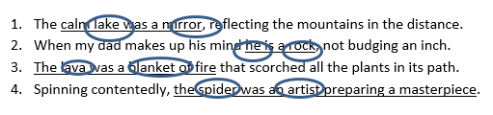
Assignment 7

1. C
2. E
3. A
4. F
5. B
6. G
7. D

8. A) alliteration –repetition of ‘k’ sound B)Simile – use of ‘as’
9. A) Onomatopoeia –the word ‘ribbit’ indicates that a sound is being made
B) Personification –the animals are using the human characteristic of speech

Assignment 8 ”Main Street”
1. A Only choice A emphasizes that the character was expecting something other than what she sees. The language the author uses: “unprotected and unprotecting” and “no dignity” is the reality. Her seeing “no dignity... nor any hope of greatness” suggests that she had higher expectations
2. A Only choice A accurately describes the character in a way that is supported by the text. Her eagerness can be seen in phrases like “a great many people” and “would be so lovely.” Her doubt is seen in her questioning of her own memories of what she had seen: “hadn’t they?
3. A Only choice A accurately describes the character in a way that is supported by the text. Her eagerness can be seen in phrases like “a great many people” and “would be so lovely.” Her doubt is seen in her questioning of her own memories of what she had seen: “hadn’t they?”

Assignment 9 The Great Debate
1. The correct answer is E.
A) The debating styles of John Kennedy and Richard Nixon during the 1960 Great Debates were similar, since TV viewers and radio listeners ended up with different opinions of who won the debates.
B) The candidates had similar agendas and arguments, so domestic issues were not pivotal.
C) Richard Nixon was not sick at the time of the 1960 Great Debates. He was thin and pale, but there is no mention that he was sick.
D) The number of television viewers who tuned in to the 1960 Great Debates was not the author’s main concern.
E) Correct. The effect of television on the results of the 1960 Great Debates was the main concern of the author
2. The correct answer is C.
A) Kennedy was not a better debater than Nixon: people who followed the debates on radio thought Nixon had won the debates.
B) Nixon was not the unequivocal winner of the 1960 debates; people who watched the debates on TV thought Kennedy was the winner.
C) Correct. The Democrat beat the Republican in the 1960 election; there was a party shuffle. This is mentioned in the last line (21) of the passage. Since Nixon, the
Republican, was the incumbent, the shuffle resulted in Democrats taking office.
D) There is no mention of whether Nixon was more prepared for the first debate than
Kennedy. Kennedy rehearsed the day of the debate.
E) Kennedy and Nixon did not disagree strongly on issues on the home front. They had similar agendas and arguments.

3. The correct answer is E.
A) He had a five o’clock shadow during the first debate. While this fact is widely known, it is not mentioned in the passage.
B) He did not wear a brown suit during the first debate. His suit was obscured by the ashen–colored – gray – paint.
C) Whether Nixon warned of the impending Cuban crisis was not mentioned in the passage.
D) Whether Nixon limped is not mentioned in the passage.
E) Correct. Nixon lost his job after the election. Since there was a party shuffle, the incumbent lost his job. The incumbent Vice President was Richard Nixon.

Assignment 10: JFK’s Inaugural Speech

1. The torch refers to leadership and political power. The new generation must defend freedom, as “heirs of the first revolution.” It applies to President Kennedy as he was the youngest elected President and was the first born in the 20th century. Therefore, JFK was part of the new generation.

2. The tiger represents the people. Kennedy is warning dictators that trying to get power by suppressing the people ends with the people rising in a revolt against tyranny. The dictator may be “eaten” by the people’s desire for freedom.

Assignment 11: Summary

Answers will vary but should include;
• President Kennedy’s speech is urging this generation of Americans to rally and show their patriotism and their love of freedom.
• He ask them to look back to the past generations for an example of national loyalty and to become a part of history in the making by leading the country against the common enemies of man.
• The famous quote,” Ask not what your country can do for you –ask what you can do for your country” comes from this speech.

Example:
The main idea of John F Kennedy’s Inaugural speech was for the people of the United States to become a unity that supports freedom and human rights for all mankind. President Kennedy reminded the people of the past generations’ national loyalty and encouraged them to become a part of history by leading the country against the common enemies of man. This speech includes the famous quote, “Ask not what your country can do for you-ask what you can do for your country”

Assignment 12: Economics

Economy - What is it?
- F
- F
- T
- F
- T

Supply and Demands
- F
- F
- T

Recession
- T
- T - True (Depression is a more severe downturn than a recession)
- F - False - b (It refers to periods of growth as well as periods of stagnation or decline)
- F

Scarcity and Choice Section
1. 450 sandwiches: Point A
2. 150 sandwiches ; 300 subs
3. 50 sandwiches; at Point B, Sam would be producing 50 fewer sandwiches that he could produce.
4. 150 subs; at Point C, Sam would be producing 150 fewer subs that he could produce
5. D. Scarcity exits because people have many wants and needs, but they have limited resources (money and time).
6. B. Production possibility curves show the number of items a supplier can produce when the supplier is making more of one item.

Lesson 8 Math

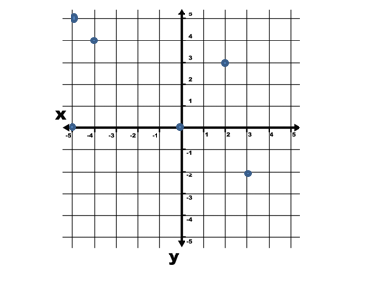
- The Origin

Assignment 2
Domain  x | Range  y
-1 | 0
1 | -2
1 | 3
4 | 5
3 | 3
5 | 6
7 | 0
8. No, this relation is not a function. In the domain, 1 maps to both 2 and 4 in the range
9. Yes, this relation is a function. While the domain values of 2 and 3 both map to 4, each input has only one output.
Assignment 3
1. 6.0, 6.6, 6.8, 7.6
2. 4.2, 5.0, 5.2, 6.4
3. A
4. C
5. C.
6. Domain: (0, 1, 2, 3, 4,)
Range: (25000, 21250, 17500, 13750, 10000)
Yes, this relation is a function. Each input has exactly one output.
Assignment 4
1. A. Any vertical line you look at on this graph passes through only one point at a time
2. B. A vertical line would pass through two points at the same time
3. B. A vertical line would pass through two points at the same time
4. A. Any vertical line you look at on this graph passes through only one point at a time
Assignment 5
1. C = domain F = range
2. Domain: (0, 10, 25, 35)
Range: (32, 50, 77, 95)
3. Inverse: (32,0), 50,10), (77,25), (95,35)
Relation | Inverse
(-6,0) | (0,-6)
(-3,-2) | (-2,-3)
(0,-3) | (-3,0)
(1,4) | (4,1)
(2,1) | (1,2)
(5,-2) | (-2,5)

5.
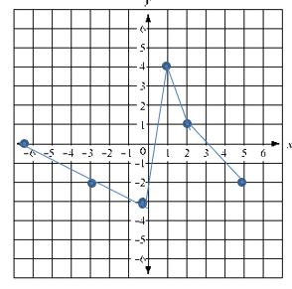

6. Yes this relation is a function. Each value in the domain maps to exactly one value in the range.
7.
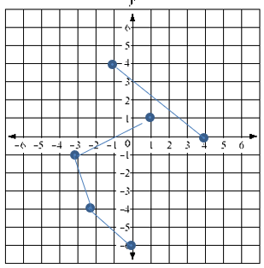
8. No. The inverse of the relation is not a function. In the domain of the inverse, −2 maps to both −3 and 5 in the range of the inverse.

Assignment 6
Vocabulary to know
1. Domain- the set of inputs, or the x-coordinates
2. Range - the set of outputs, or the y- coordinates
3. Inverse- the reversed order of the relation from domain to range. That is, instead of order (x,y) the inverse is (y,x). (To find the inverse of the relation, switch the x and y coordinates.)
4. Function- a special type of relation where each input has exactly one output.
5. Relation - a rule that gives an output for every valid input
6. Vertical line test - a means of testing for a function. (If you can draw a vertical line on a graph that passes through more than one point, the relation is not a function.)
Assignment 7
5. Complete the table of values for the equation y = 2x.
Graph y=2x

x | y
-2 | -4
-1 | -2
0 | 0
1 | 2
2 | 4

You did not have to choose these x values. Plug the x values you choose into the equation y=2x and then solve for y
y=2x
y=2(-2)
y= -4

6. Now, graph the equation by plotting the points. Unable to graph (3,8)
Graph y=2x

x | y
0 | -1
1 | 2
2 | 5
3 | 8

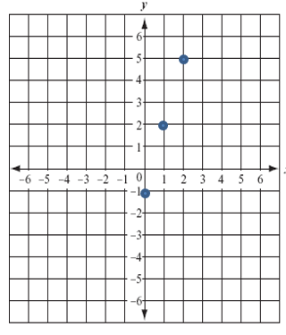
Assignment 8

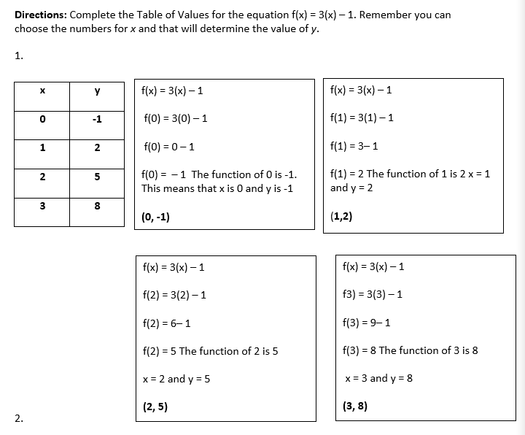

1. (0,-1)
2. (1, 2)
3. (2, 5)
4. (3, 8)
Assignment 9
1. Y-int = 18 initial velocity = 129ft/sec
m= -32 ft/sec
The speed is decreasing at 32 feet a second.
2. Fisherman in the Finger Lakes Region have been recording the dead fish they encounter while fishing the region. The Department of Environmental Conservation monitors the pollution index for the Finger Lakes Region. The model for the number of fish deaths “y” for a given pollution index “x” is y=9.607x + 111.958. What is the meaning of the slope? What is the meaning of the y-intercept?

What is the slope? It is m = 9.607. This value represents, for every increase by 1 in the input variable x, an increase of 9.607 in the output variable y.

What is the meaning of the slope? In means that, for every increase in the pollution index by one unit (say, from a pollution index of 6 to a pollution index of 7), there are nine or ten more fish deaths during the year.

Lesson 9
Language Arts, Social Studies and Science

Assignment 1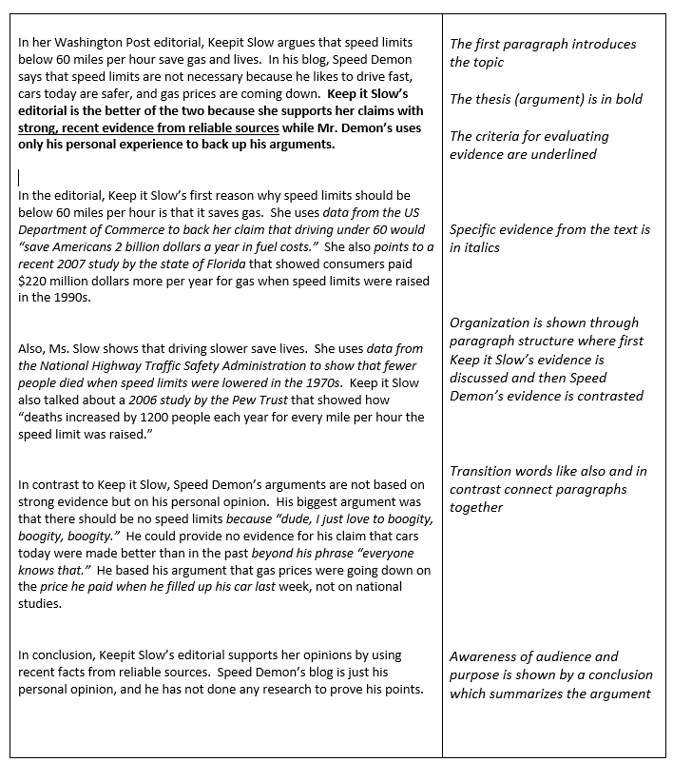

Assignment 2

1. C
2. E
3. D
4. A
5. C
6. D
7. B

Assignment 3: The Hubble
1. A.
2. C
3. E.
4. A
5. B
6. C
7. C

Assignment 4: Manifest Destiny

1. O’Sullivan believes America to stand for a nation of progress, of individual freedom, and of universal enfranchisement (the right to vote).
2. According to O’Sullivan America’s mission is to establish on earth the moral dignity and salvation of man—the undeniable truth and goodness of God.
3. O’Sullivan may mean that God has freely given America this land so that the growth of the people can continue.
4. According to these two articles, it seems that the American people were not entirely in favor of the manifest destiny idea. O’Sullivan encourages them “not to doubt” in “The Great Nation of Futurity”, and in “Annexation” says it is time for all opposition to stop.

Lesson 9 Math

Assignment 1

Section A
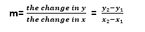
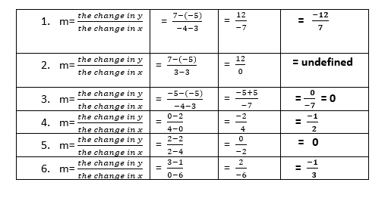

Section B∙
7. 5/3

8. ⅔

9.-4/7
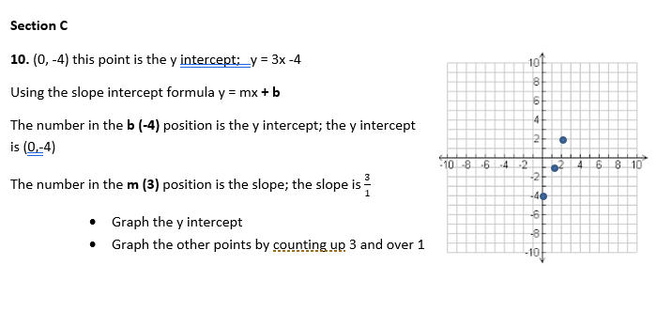

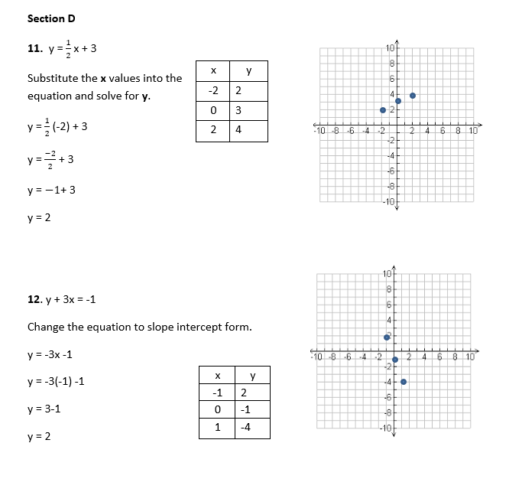
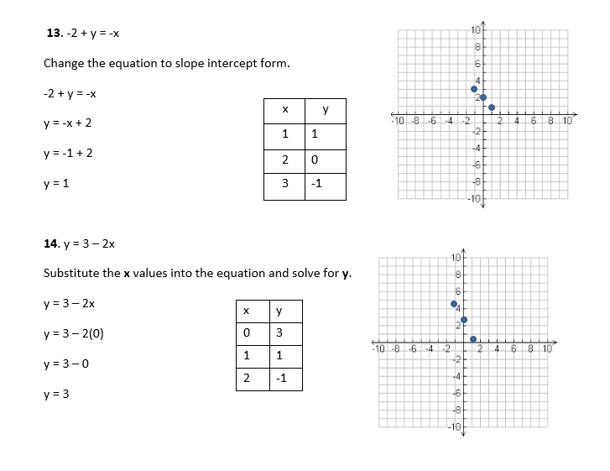

Assignment 2
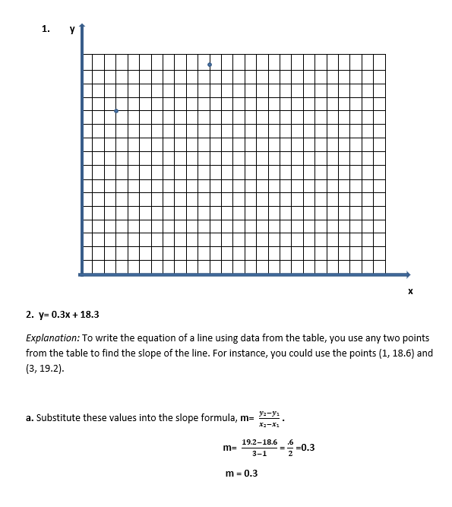
b. Then substitute 0.3 for m and the x-and y- coordinates from one of the points in the table into the slope-intercept form of a linear equation, y= mx + b.
y = mx + b
18.6 = 0.3 (1) + b
18.6 = 0.3 + b
18.6 - 0.3 = b
18.3 = b

Assignment 3: Pythagorean Theorem

1. h = 14.4
Use the formula $a^{2}$+ $b^{2}$= $c^{2}$
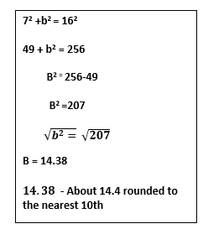
2. X = 10.2 ( Rounded to the nearest 10th)

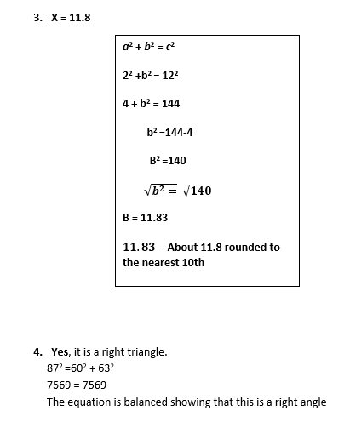
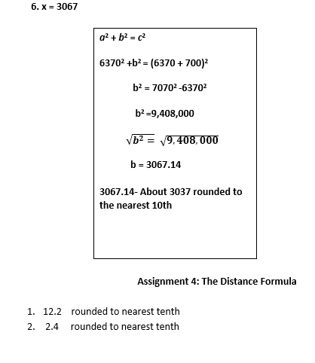

Lesson 10 Language Arts, Social Studies, and Science

Assignment 1
1. D

Assignment 2
1. D
2. A
3. C –“the passage states that sometimes living donors can donate because it is possible to live a normal life with only one of a par of organs,…”
4. D

Assignment 3
1. D
In the first paragraph, the author notes that fans are partially responsible for players’ violent hits, writing, “the sports media and fans alike bear some of the responsibility.” This is interpreted in the final paragraph when the author writes, “Sports media producers have become accustomed to showcasing the most aggressive tackles” and “NFL broadcasts often replay especially violent collisions, while the commentators marvel at the physical prowess of the players involved.” Using this information, we can infer that the sports entertainment industry does these things to boost ratings, because fans are more likely to watch when violence is on display. If broadcasters collectively decided to stop glorifying violent tackles and fans stopped choosing programming based on them, the players would be less likely to hit each other with devastating force. Therefore, (D) is correct
2. C
In paragraph 2, the author writes, “the National Football League (NFL) has revised its safety regulations,” before detailing specific ways in which the NFL has tried to combat the problem of CTE. Therefore, (C) is correct because the author does not suggest that the NFL has done “nothing to address the problem.” In paragraph 3, the author writes, “With appropriate equipment and form, tackling need not be dangerous.” Using this information we can see that tackling can be done safely.
3. E
In paragraph 3, the author writes, “Youth, high school, and college leagues should also adopt safety rules even more stringent that the NFL’s.” The author suggests that NFL standards may protect professional players, but the regulations for amateurs are not as strict, if they exist at all, as those for professional players. Therefore, increased NFL safety standards do not directly address the injuries suffered by amateurs, who have fewer, or less strict safety regulations. This supports option (I). In paragraph 3, the author writes, “at an early age athletes should be educated about the serious dangers of head injuries.” Using this information, we can see that youth are not educated properly. This supports option (II). In the final paragraph, the author argues that “amateurs” are “likely to try to imitate their favorite NFL athletes” when they watch violent highlight reels on sports programs. This supports option (III). Therefore, (E) is correct.
4. A
laudable (adjective): worthy of praise; commendable.
In paragraph 3, the author writes, “Efforts by the NFL and other professional sports leagues are certainly laudable; indeed, we should commend every attempt to protect the mental and physical health of players.” If we should “commend” these attempts, and another word for commend is praise, then to say that the efforts are praiseworthy (worthy of praise) is the same as saying they are laudable. Therefore, (A) is correct. Ineffective means without producing results.
5. D
An author’s tone is directly related to the language, content, and imagery of a passage. In the final paragraph, the author writes, “Players must stop being encouraged to trade their careers, health, happiness, and their lives for the sake of a game.” A solemn tone is serious. Using the above information, we sense that the author views the potential death of athletes—simply for the sake of a game—as a solemn or serious matter. The author’s tone is thus solemn, as the adamant language is used to persuade us that CTE is not just a serious threat to football players’ health, but that it could also end their lives. If we look at the syntax—the arrangement of the words—we also see a progression from the less serious (loss of career), to the most solemn consequence (death). This structure furthers the development of the solemn tone in the final paragraph. Therefore, (D) is correct.

6. E
exalt (verb): to praise or glorify something or somebody.
In the final paragraph, the author writes, “When the media exalts such hazardous behavior, professionals are rewarded for injuring each other on the field, and amateurs become more likely to try to imitate their favorite NFL athletes.” Using context, we can see that professional players are rewarded when the media exalts their hazardous behavior. We can also use the sentence immediately following it—which suggests an appropriate response—to provide context clues: “Announcers, commentators, television producers, and sportswriters should engage in a collective effort to cease glorifying brutal plays.” Using this information, we can see that the author believes that “glorifying brutal plays” needs to stop. Thus, using the information above, exalt must mean to reward or to glorify. We know that we are looking for the word that most nearly means the opposite of reward or glorify. Criticize means to be critical of, scold, or find flaws with, which is quite opposite of rewarding or glorifying something. Likewise, if the media were critical of the players for hitting violently, the behavior would be less likely to continue. Therefore (E) is correct
7. B
In the last sentence, the author urges players to stop trading “their careers, their health, their happiness, and their lives for the sake of a game.” The ideas progress from least crucial (careers) to most crucial (lives). Organizing ideas in order of ascending power or importance is called climax. Therefore, (B) is correct.
Questions 8,9, 10 and 11
Answers will vary. Students must write in complete sentences and show connected thought patterns.
Assignment 4
1. C
2. B
3. A
4. D
5. B
6. A
7. C
8. Suggested answer: According to Martin Luther King Jr., we need nonviolent gadflies to create the kind of tension in society that will help men rise from prejudice and racism to understanding and brotherhood.
9. Suggested answer: Martin Luther King Jr. used the example of Socrates to emphasize the point that constructive nonviolent tension is necessary for growth. Just as Socrates felt that it was necessary to create a tension in the mind so that people could rise from myths and half-truths in order to reach creative analysis and objective appraisal, Martin Luther King Jr. argues that tension must be created in society so that men will be able to rise from the depths of prejudice and racism to the heights of understanding and brotherhood. Thus, Martin Luther King Jr. notes the beliefs of Socrates regarding tension to support his argument that tension can be productive and help bring about needed change.
10. Suggested answer: It is clear that Martin Luther King Jr. perceived the nation as being in a gloomy state when he uses the phrase “our pending national elegy,” which suggests that the nation is facing a death of sorts, most likely a death of its own principals and promise. In addition, he is also critical of the national policy which he locates as being in “the quicksand of racial injustice,” which conveys the sense that this national policy is not stable or solid, as it can easily fall apart due to its racial injustice. However, Martin Luther King Jr. also seemed optimistic, giving hope that the promise of democracy can be made real and that the pending national elegy can be transformed into a creative psalm of brotherhood, as the funeral song can be transformed into a sacred song of brotherhood. Furthermore, he also states that the national policy can be lifted from the “quicksand of racial injustice” to the “solid rock of human dignity.” Hence,
Martin Luther King Jr. was optimistic that the promise of democracy could be realized if the opportunity was taken to do what is right.

Sample Test Answers
- E
- D
- E
- A
- B
- B
- A

Math

Assignments 1 and 2: Distributive Property Answers

1. 9 −3x

2. −8 +5n

3. −20 + 49n

4. -11+15x

5. −3 −16x

6. 35n+ 30

7. 35n−9

8. −56x+ 21

9. −7 −6x

10. −40n+ 21

11.−3 −6n
12.
Simplify 5 + 2{ [3 + (2x – 1) + x] – 2}
5 + 2{ [3 + (2x – 1) + x] – 2}
5 + 2{ [3 + 2x – 1 + x] – 2}
5 + 2{ [2x + x + 3 – 1] – 2}
5 + 2{ [3x + 2] – 2}
5 + 2{3x + 2 – 2}
5 + 2{3x}
5 + 6x
6x + 5

Assignment 3

1.17

2. 6

3. 15

4. 13

5. 14

6. 16

7. 4

8. 12

Assignment 4

2√7

2√3

2√5

3√x

Assignment 5

√33

√25 = 5

3√6

3√10

6√7x

6√x

Assignment 6

1. 11√2

2. 5√5

3. -12√10

4. 5√6

5. 16√3

6. 4√5

Sample Test Answers Needed

1. E
2. E
3. C
4. D
5. B
6. D
7. A
8. B
9. B
10. C
11. D
12.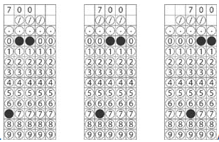
The formula for simple interest is found on the Formula page in
the front of the GED Mathematics Test and at the beginning of this
group of questions.
simple interest = principal x rate x time
simple interest = $5000 x 0.07 x 2
simple interest = $700
To show that the answer can be right-, left-, or center-justified,
three acceptable griddings of this response are shown below.

13. 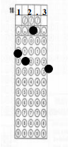
The amount of growth is the difference between this week’s
measurement and last week’s measurement.
amount of growth = this week’s measure – last week’s measure
amount of growth = 28.4 – 16.1
amount of growth = 12.3 (centimeters)
One acceptable gridding of this response is shown below

14.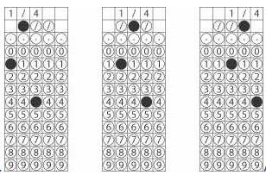
Since Kyle is serving 4 from a recipe designed for 8, he needs
4/8, or ½, the amount of each ingredient. One half of ½ teaspoon is
found by multiplying.
(1/2) x (1/2) = 1/4
This could be gridded using the decimal equivalent of ¼, namely
0.25, but the fraction is gridded below to illustrate the use of the
fraction bar.

15.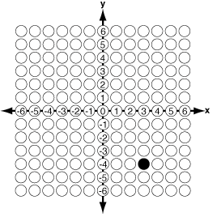

The coordinates in the ordered pair are listed with the x-, or
horizontal, coordinate first and the y-, or vertical, coordinate second.
The point (3, -4) is located in the lower-right, or fourth, quadrant of
the graph.

