Error Correction

Errors are evidence of the learner engaging in the process of learning a second language. Errors are a natural and assumed part of the learner's interlanguage (The linguistic system a learner creates on the path to acquisition).
Because learner errors are a natural part of language acquisition, there is a range of ways to address them. Here are six common error correction techniques.

- Explicit Correction
The first technique is explicit correction—the teacher clearly indicates the error and provides the correct form.
This sort of correction tends to address only form, not the intended meaning.
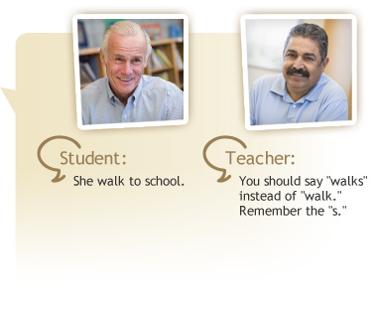

Think About It
In this example of an explicit correction, the teacher focused solely on the error.
How could the teacher adjust this response to seem more authentic to the student?
The teacher could respond to the meaning the student expressed after offering the explicit correction to make the interaction more authentic. To respond authentically to the meaning, the teacher could ask:
- How far does she have to walk?
- Does she walk to school alone?, or
- What if it is raining? Do you take her?

Clarification Request
Teachers use clarification requests to inform students that what they said was unclear or in error and needs to be repeated or rephrased. Typically, the teacher uses phrases such as "Pardon me?" or "I don't understand."
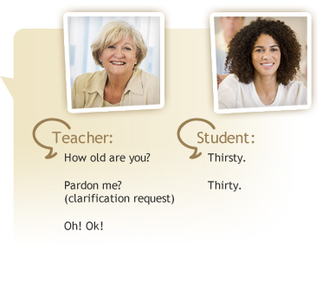

Recast Correction
The recast correction is one of the most frequently used forms of correction. The teacher rephrases the student's error, or provides the correction, but does not specifically identify the error.
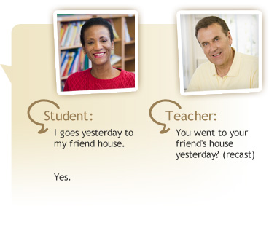

Recast Correction . . . May Not Be Noticed
Teachers use recasts a great deal because they do not interrupt the flow of conversation. They do not always help students notice errors, however, particularly when addressing multiple errors.
In this example, the recast addressed noun-verb agreement, word order, and the possessive "friend's." It is not clear from the student's response if the corrections were noted or if the student just responded to the teacher's confirmation about the meaning of the sentence.

Elicitation
Teachers use the elicitation technique to encourage students to correct an error by asking questions, pausing to allow sentence completion, or directly asking them to rephrase.
In this example, the teacher uses explicit correction first, then uses elicitation to encourage the student to rephrase the sentence.
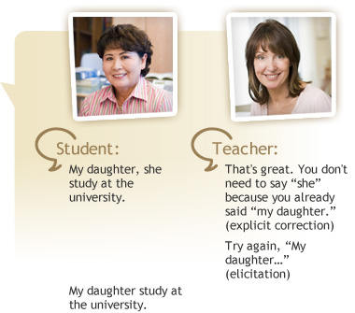

Think About It
In this example, the teacher used both explicit correction and the elicitation technique, but the student did not correct the verb agreement problem.
What might the teacher do next? Since the teacher already used two techniques to elicit the correct phrasing, she tries a recast, "My daughter studies at the university." This allows the conversation to continue, but the student may or may not note the correction.
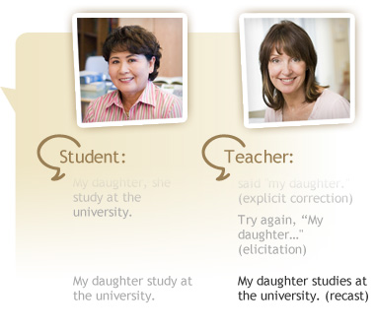

Metalinguistic Feedback
Metalinguistic feedback uses formal grammatical terminology to indicate the error. The teacher uses words such as "plural" and "verb" with the assumption that these terms carry meaning for the student. This technique is most successful with literate students familiar with grammatical terminology.
Notice how the teacher combines this feedback with elicitation to prompt the student to correct the sentence.
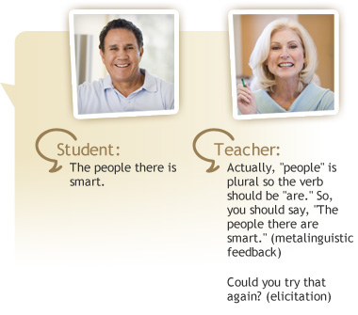

Repetition
In the final technique—the repetition technique—the teacher repeats the error with rising intonation.
In the example provided, the student reformats the sentence in response to the repetition, but it still contains an error. A follow-up recast is required to produce an accurate repetition. When the error is not stated explicitly, the teacher may need to use multiple techniques.
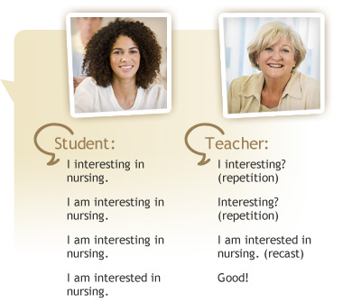

Technique | Description
Explicit correction | Teacher clearly indicates the error and provides the correct form.
Clarification request | Teacher uses phrases like "Pardon me?" or "I don't understand." to indicate an error or lack of clarity, and the need to repeat or rephrase.
Recast correction | Teacher implicitly rephrases the student's error or provides the correction, but does not directly indicate the student's error.
Elicitation | Teacher asks questions, pauses to allow sentence completion, or asks students to rephrase, to elicit the correct form from the student.
Metalinguistic feedback | Teacher uses formal grammatical terminology to indicate an error.
Repetition | Teacher repeats the error with rising intonation to call attention to it.

Responding to Errors
Decisions about how to respond to errors are complex. Teachers must decide how, and even whether, they should correct the learner.
The selection of the response may be driven by the purpose of the activity taking place. For example, the response may focus on:
- Resolving a genuine misunderstanding
- Correcting linguistic forms already taught
- Understanding the learner's intended meaning (and ignoring the error)

Characteristics of Feedback
Corrective feedback techniques are differentiated by the presence or absence of three important components:
- Indication of the error
- Provision of the correct form
- Elicitation of the correction
Teachers need to consider which of these elements are needed when selecting a feedback technique. Often, multiple techniques are required to elicit the desired response.

Consider Learner and Circumstances
Teachers can often tailor error correction techniques to specific learners and circumstances.
For instance, it is not helpful to use metalinguistic language if learners do not know parts of speech. Also, it may not be appropriate to respond to form over meaning, particularly when the student wants to communicate something personal.

Overcorrection
Overcorrection can result in students taking fewer risks in class, speaking less, and failing to develop fluency skills.
Within a thematic unit, some teachers focus their instruction and assessment on particular forms and try to direct their corrective feedback mainly to those forms. This gives all students more opportunities to analyze, produce, and attend to a particular form, such as progressive tense.

Other Types of Interactions
Error correction is only one type of classroom interaction. It is important to explore other types of interactions, such as types of questions teachers ask, equitable participation among all members of the learning community, interactional styles of students, and the quality of student-student interaction.
A big challenge is giving students the opportunity to speak more than a few words at a time. Because the teacher dominates the class, students do not have the opportunity to produce extended discourses, or the tasks are not designed to give students opportunities to produce discourses at the sentence or paragraph level.

